ØØ Explanation :
Let the 8 bit number be in the A register. We have to mask the upper nibble i.e. we have to separate the upper nibble. In the result only LSB number should be present.
e.g. : AL = 67H. | 0110 | 0111
Logically AND with 0FH | 0000 | 1111
 | 0000 | 0111 | = 07H
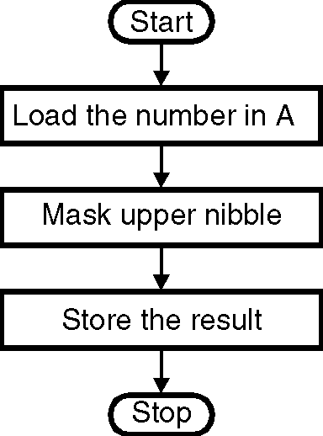
Result = 07 H, 6 is masked.
Store the result.
ØØ Algorithm :
Step I : Load the number in A.
Step II : Mask the upper nibble.
Step III : Store the result in register B.
Step IV : Stop.
ØØ Flowchart : Refer flowchart 12.
Flowchart 12
ØØ Program :
Instruction Comments
ANI 0F H ; Logically AND the number
MOV B, A ; Store the result.
HLT ; Terminate the execution

